FURTHER MATHEMATICS (Unit 3)

APPLICATION TASK(SAC), 2018 SOLUTION ADVICE

CORE: Data Analysis
REACTION TIMES

Start date: ______________ End date: _________________

Time: insert number of class periods (Total Time 4-6 hours)

The SAC is designed to run in 3 sittings (3 parts)

Student Name: ____________________________________________________________

Student Number: ___________________________________________________

INTRODUCTION:
In senior science students have been testing their reaction time with their dominant and non-dominant hands. They use a computer program and must click on an object when a pattern appears firstly with their dominant hand and then their non-dominant hand. Their reaction time in seconds is recorded.

The Head of Science Mrs. Beaker is interested in a few different research questions.
- Is there a difference between sex and reaction time?
- Is there a difference between sex and dominant and non-dominant hand reaction time?
- Is it possible to predict a person’s non-dominant hand reaction time from their dominant hand reaction time?
These questions and others will be investigated in this assessment
Using the data given to you in the excel spreadsheet, answer the following questions.

Data from ABS website: http://www.cas.abs.gov.au/cgi-local/cassampler.pl
Part 1:
- Represent the reaction times for female dominant and non-dominant hand reaction times in an appropriate graphical display. Calculate appropriate statistics to 2 decimal places.
Label all axes.

Dominant hand reaction times
Min = 0.28, Q1 = 0.38, Med = 0.41, Q3 = 0.44, Max = 0.79
IQR = 0.06
Non-dominant hand reaction times
Min = 0.29, Q1 = 0.38, Med = 0.47, Q3 = 0.63, Max = 0.89
IQR = 0.25

Appropriate graphical displays are a back to back stem plot or parallel boxplots.

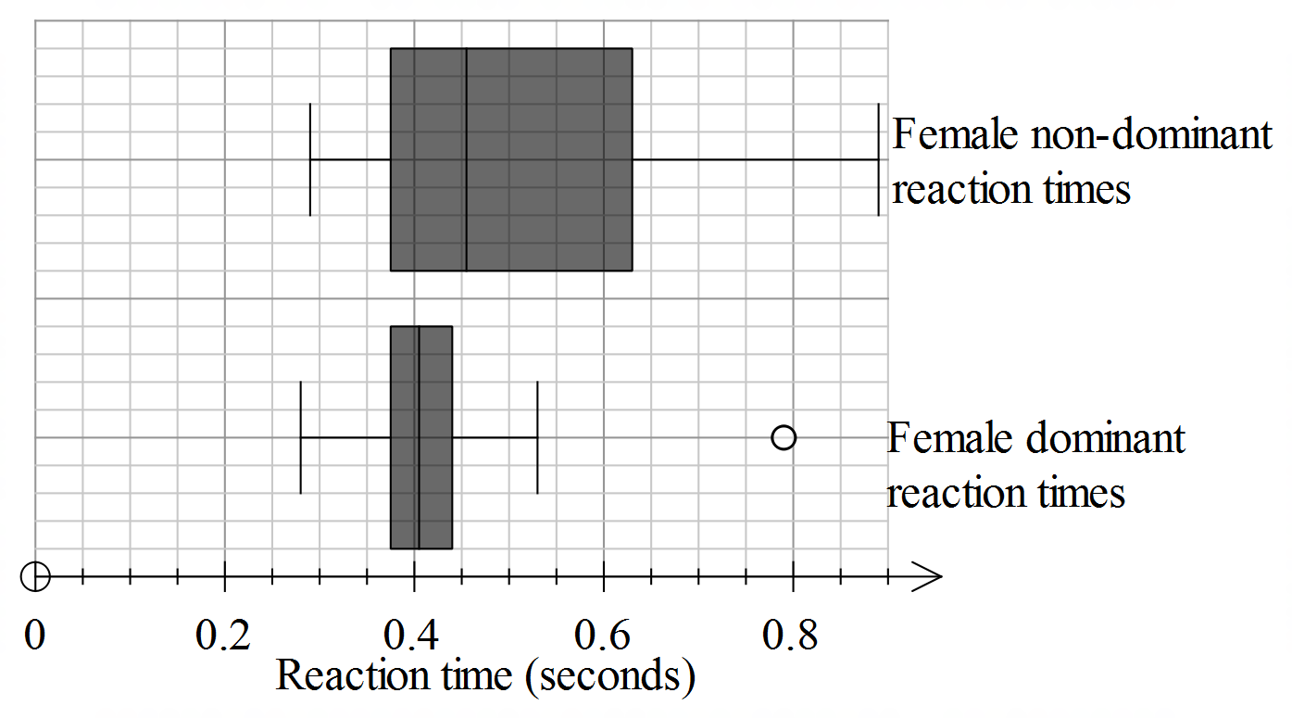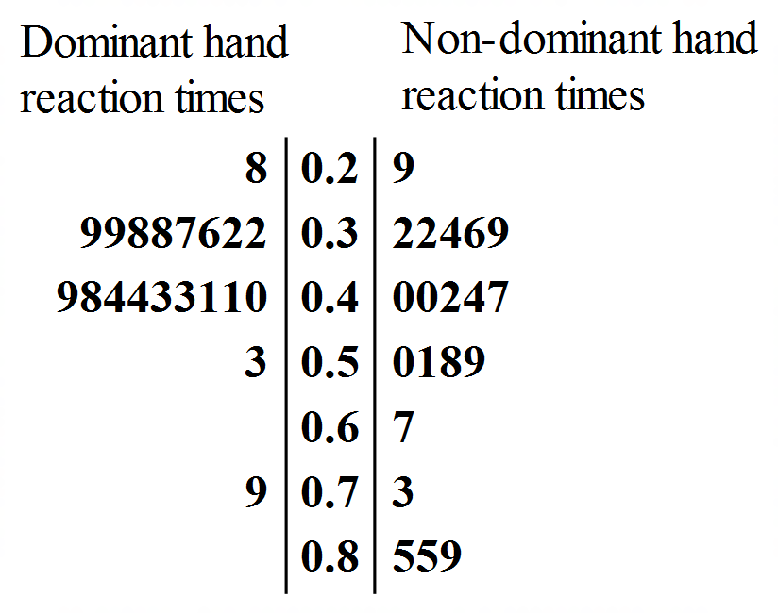
3M – statistics for dominant hand reaction times
3M – statistics for non-dominant hand reaction times
2M – correct graph
(8 marks)

- Explain why you chose the graphical representation in Question 1.
The data has a categorical variable with two categories and a numerical variable therefore an appropriate graphical display is a parallel boxplot or back to back stem plot.
- marks)
- Compare the two distributions in terms of shape, centre and spread. Give appropriate statistics to justify your responses
The female dominant hand reaction time distribution is symmetrical with an outlier at 0.79. The distribution is centred at the median of 0.41. The spread of the distribution measured by the range is 0.51.
The female non-dominant hand reaction time distribution is positively skewed with no outliers. The distribution is centred at the median of 0.47. The spread of the distribution measured by the range is 0.6.
(3 marks)
- Comment on how the non-dominant reaction times for females compare to the dominant reaction times for females for the data.
The non-dominant hand reaction times are more variable than the dominant hand reaction times as the range is 0.6 compared to 0.51. The centre is also higher for the non-dominant hand reaction times with a median of 0.47 compared to the median for dominant hand reaction times of 0.41.
(2 marks)
- Represent the reaction times for male dominant and non-dominant hand reaction times in an appropriate graphical display. Calculate appropriate statistics to 2 decimal places.
Label all axes necessary.
Dominant hand reaction times
Min = 0.18, Q1 = 0.26, Med = 0.33, Q3 = 0.40, Max = 0.43
IQR = 0.14
Non-dominant hand reaction times
Min = 0.25, Q1 = 0.34, Med = 0.40, Q3 = 0.43, Max = 0.63
IQR = 0.09

Appropriate graphical displays are a back to back stem plot or parallel boxplots.

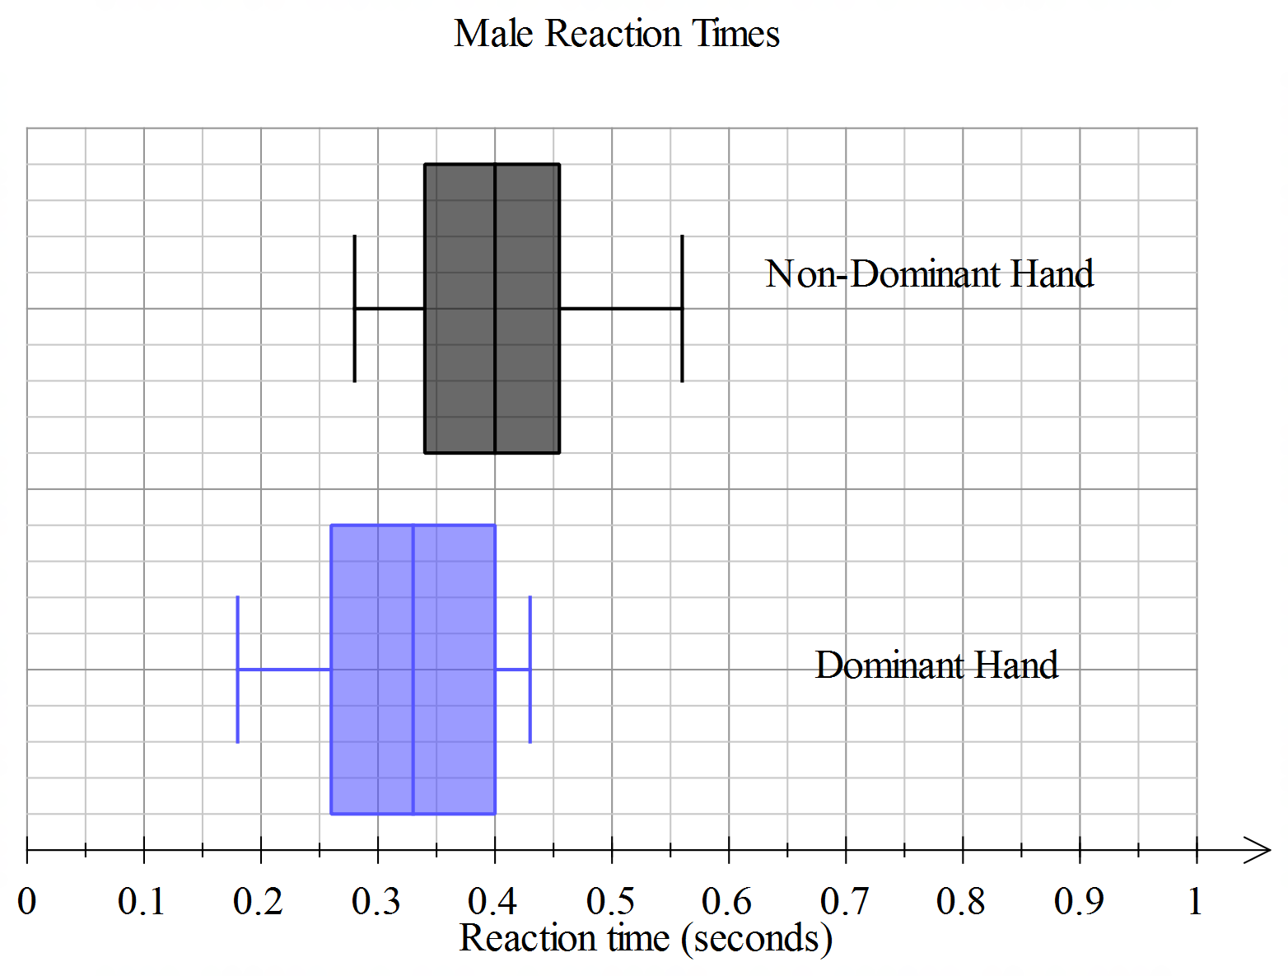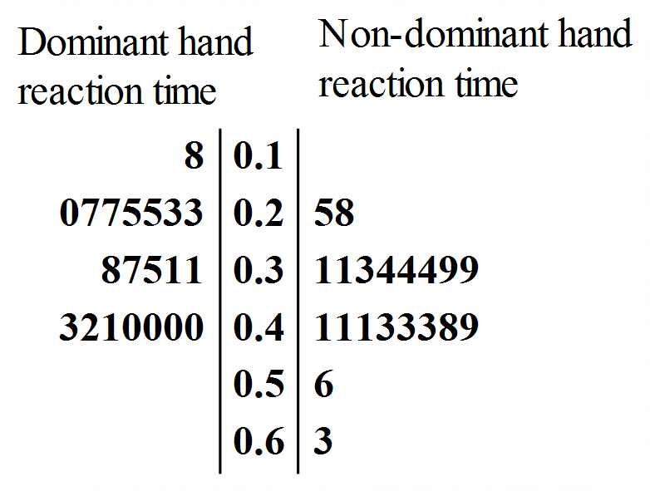

3M – statistics for dominant hand reaction times
3M – statistics for non-dominant hand reaction times
2M – correct graph
(8 marks)
- Compare the two distributions in terms of shape, centre and spread. Give appropriate statistics to justify your responses.
The shape of both distributions is approximately symmetrical with no outliers. The centre of the dominant hand reaction time is lower than the non-dominant hand reaction times with median values 0.33 and 0.4 respectively. The non-dominant hand reaction times were more variable with a range of 0.38 compared to dominant hand reaction times with a range of 0.25.

(3 marks)
- Using the information from the graph in Q5, explain why the reaction time for males is associated with the hand used (dominant or non-dominant). Quote the values of appropriate statistics in your response.

Reaction time for males is associated with hand use as the median value for non-dominant hand is higher (0.4) than the median value for dominant hand (0.33).

(2 marks).

Part 2
- Construct a histogram showing the dominant reaction times on the axes below. Select a suitable width and justify your choice.
Various answers acceptable.
Example: Width chosen is 0.1. This was chosen because it gave 7 bins and it is recommended histograms have between 5 to 20 bins. (2M)
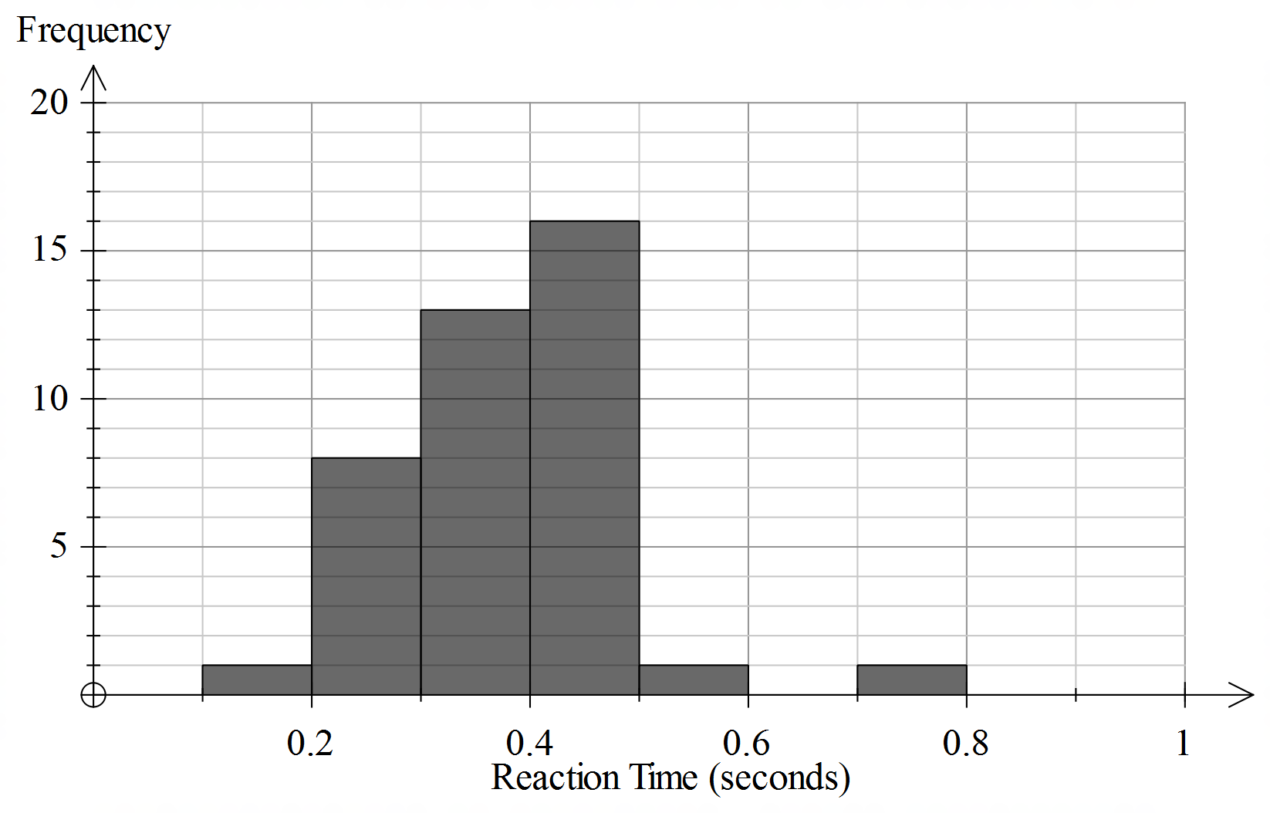
(2M – correct histogram)
(4 marks)
- Describe the shape of the histogram in terms of shape, centre and spread
Positively skewed.
(1 mark)
- Which measure of centre gives the best indication of the dominant hand reaction times? Explain your answer?

The median would be the best measure of centre to use as the data is skewed.

- Calculate the % of people with a reaction time below 0.3
8/40 * 100 = 20

(2 marks)

Below is a histogram of the non-dominant hand reaction times
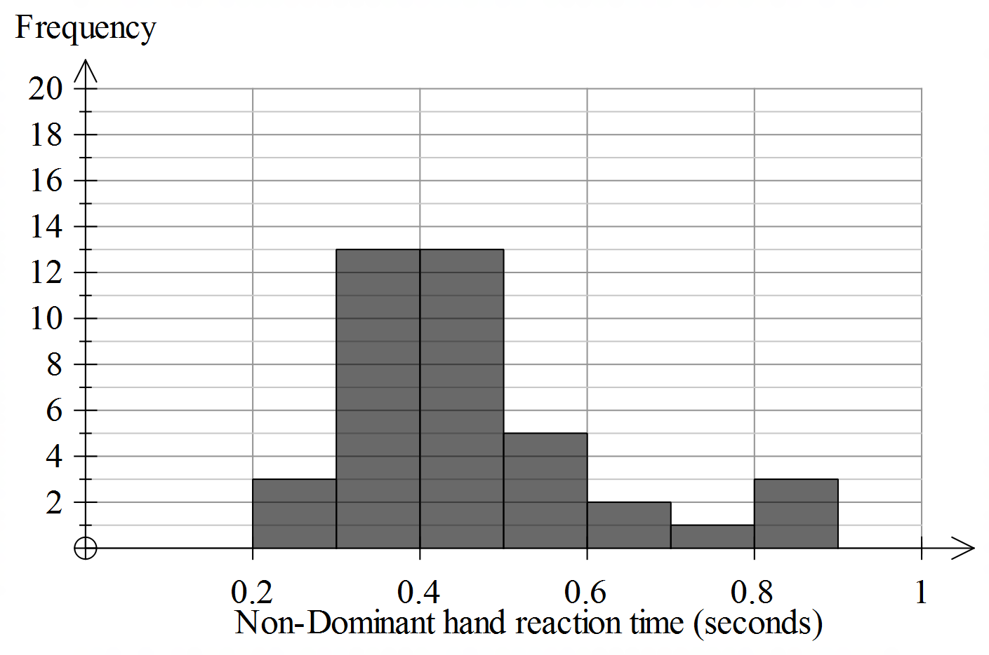

- Describe the shape of the histogram in terms of shape, centre and spread.
The shape of the distribution is positively skewed. It is centred at 0.4 seconds and the spread of the data is 0.7.
(3 marks)
- Mrs Beaker wants to apply the 68-95-99.7% rule to the non-dominant hand reaction times as shown in the histogram in Q7. Explain why the 68-95-99.7% should not be used with this data.
The 68-95-99.7% rule can only be used with data that is symmetrical and since this data is skewed it should not be used.

(2 marks)

The science classes are interested in investigating whether the reaction time of a person’s dominant hand is related with the person’s reaction time of their non-dominant hand.
To investigate this, they create a scatterplot showing the relationship between reaction times for the dominant and non-dominant hands.

- Create a scatterplot and calculate the linear regression equation, correlation coefficient and correlation of determination. Interpret these statistics with respect to the context.

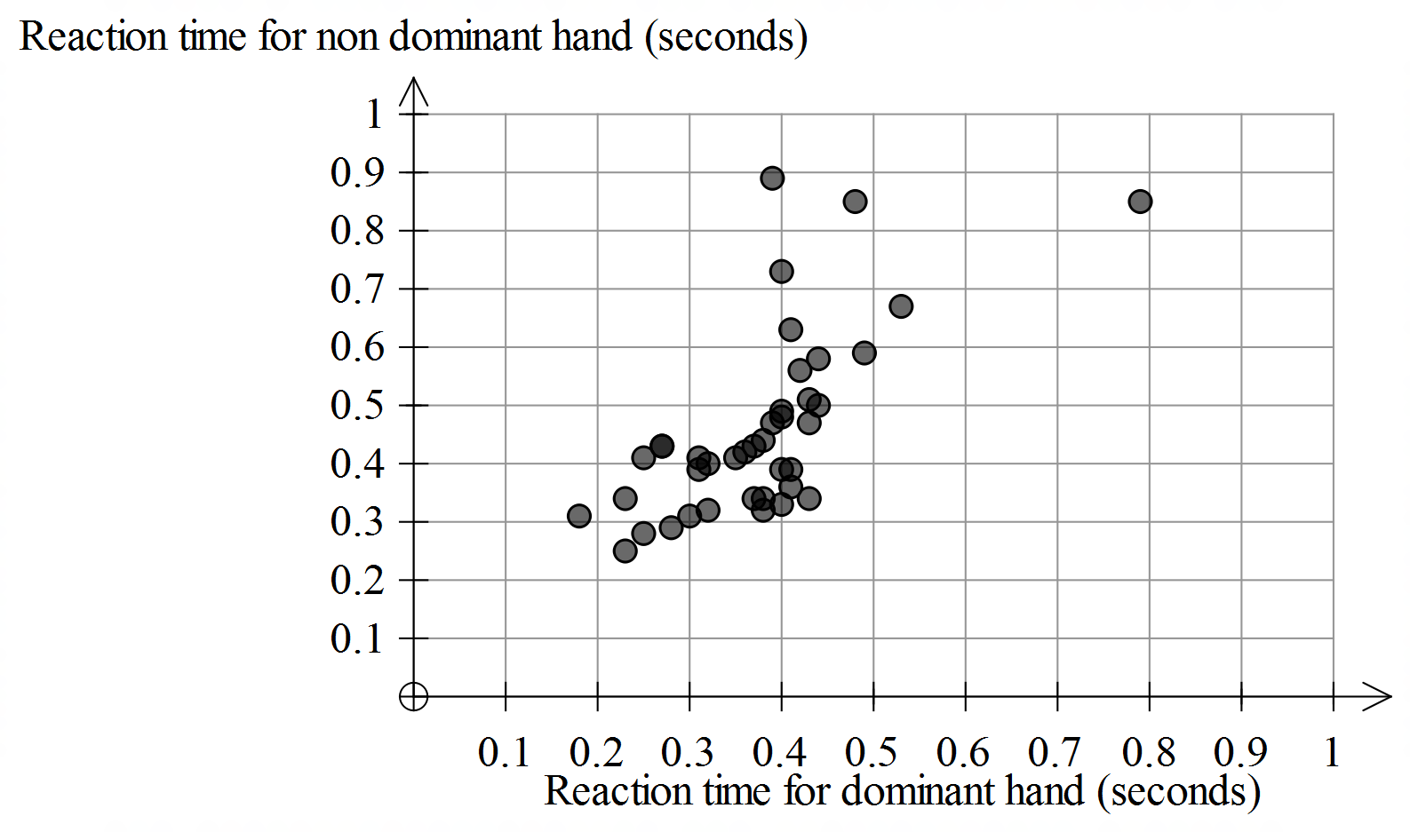
Scatterplot (2M)
RT for non-dominant hand = $0.065+1.0×RT for dominant hand$ (2M)
The correlation coefficient is 0.677 which indicates a positive, moderate, linear relationship. (2M)
The correlation of determination is 0.46. 46% of variation in reaction times for the non-dominant hand can be explained by the variation in reaction times for the dominant hand. (2M)

- marks)

- What does the y intercept and slop of the equation tell us about the data?

A gradient of 1.0 tells us that both reaction times are increasing at the same rate. So for every second that the dominate hand increases, the non-dominant reaction time increases one second.
The y intercept of 0.065 cuts the axis quite near the origin. This is consistent with the fact that both variables are measuring reaction time in seconds. This means that when the dominant hand time is 0 seconds, the non dominant hand time is 0.065 seconds

- Draw a residual plot, based on your regression line and comment on what the residual plot shows.
Based on your analysis of residuals and the scatterplot, apply three transformations to either of the variables (dominant or non-dominant hand reaction times).
Using correlation coefficients, determine the most suitable model for making predictions.

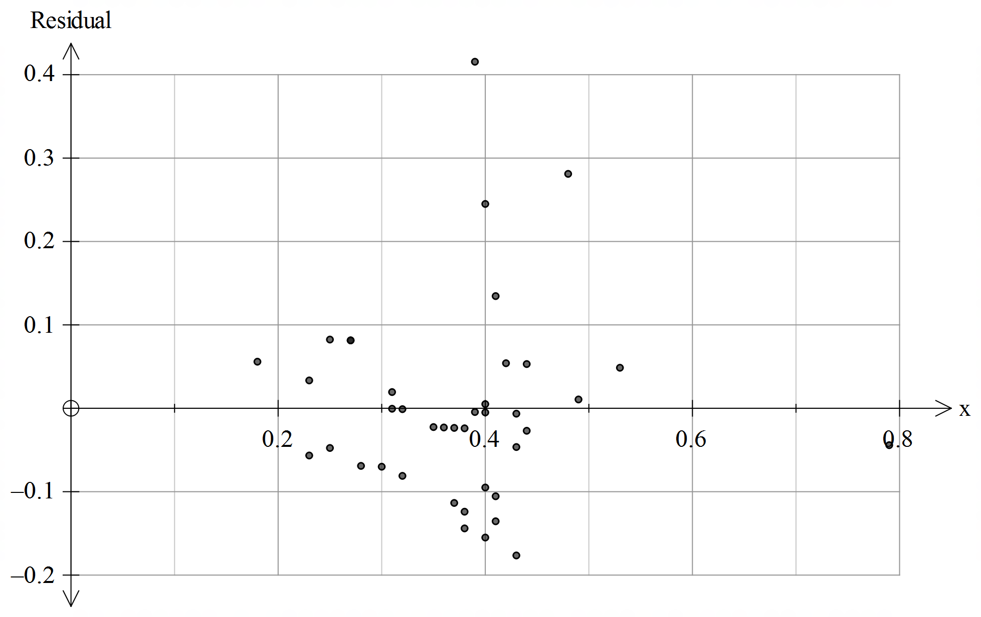

(2M for residual plot)

The residual plot shows a slightly curved pattern. (1M)

Three possible transformations based on the data would be:

Transformation | Equation of least squares regression line | Correlation coefficient
$$\frac{1}{y}$$ | $$\frac{1}{y}=-4.491x+4.082$$ | -0.669
$$\log{y}$$ | $$logy=0.905x-0.700$$ | 0.684
$$x^{2}$$ | $$y=1.103x^{2}+0.292$$ | 0.654

(6M)
The most suitable model for making predictions is the log y transformation as the r value is the closest to 1 at 0.684 compared to the original (0.677), the reciprocal (-0.669) and the squared (0.654) transformations. (2M)

(11 marks)

- Use the most suitable model to predict the non-dominant hand reaction time for two dominant hand reaction times. Select one dominant hand reaction time within the data range and select one time beyond the data range. Discuss the reliability of the predictions found.

Various answers acceptable.

Example:

Predict non-dominant hand reaction time for dominant hand reaction time of 0.36 seconds and 0.9 seconds.

$logy=0.905(0.36)-0.700$ $logy=0.905(0.9)-0.700$

$y=0.42$ $y=1.3$
(4M)
The first prediction is more reliable as it is an interpolation whereas the second prediction as less reliable as it is an extrapolation. (2M)
(6 marks)

Part 3
The senior science students undertake a 4-week program to try and improve their reaction times.
Below is a table showing how many minutes students spend on the computer completing the program from Monday to Friday.

 | Monday | Tuesday | Wednesday | Thursday | Friday
Week 1 | 6.5 | 3.5 | 10 | 6.5 | 4
Week 2 | 5.5 | 2 | 12.5 | 7 | 3.5
Week 3 | 6 | 3 | 15 | 8.5 | 5.5
Week 4 | 7 | 4.5 | 13.5 | 9 | 6

- Draw a time series plot of the minutes spent using the program over the four weeks and describe the time series plot.
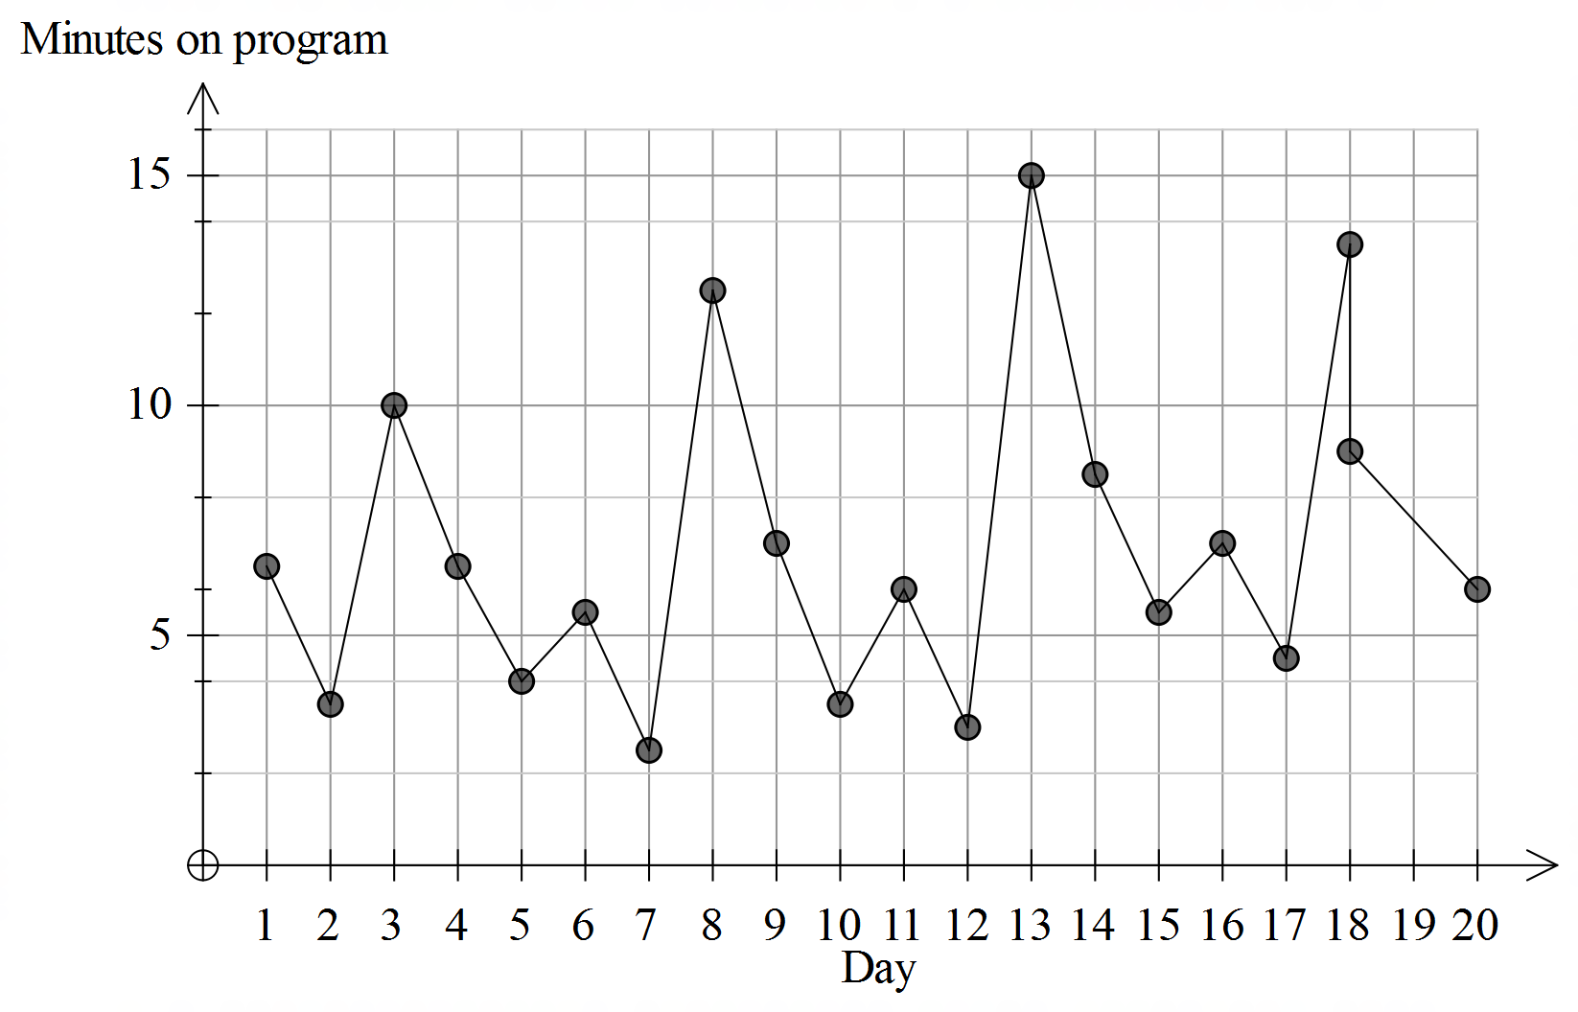
The time series plot shows a seasonal trend with a peak each Wednesday and a low each Tuesday.
- marks)

- Use an appropriate smoothing method, smooth the data, plot the smoothed data on the same time series plot using in Q1 and comment on the effectiveness of the smoothed data in revealing any underlying trends.
Various answers acceptable.
Students may choose to deseasonalise the data, use 5 moving mean smoothing or 5 point median graphical smoothing. 5-point smoothing would be appropriate as the data is based on a 5-day week.
(5M for smoothing technique and working shown)
(1M for comment on smoothed data)

- marks)

END OF SOLUTION ADVICE

